This is a drilldown of the top performing sectors by using the average 6-month percent change. We then picked the top 3 performing stocks within the top 3 sectors.

In these charts we compared the top three performing stocks within the top three sectors and conclude how they correlate to each other. We wanted to figure out which stock within each sector was doing the best among the others. We will then use metrics like P/E, 200MA, etc. to then determine relative strength.

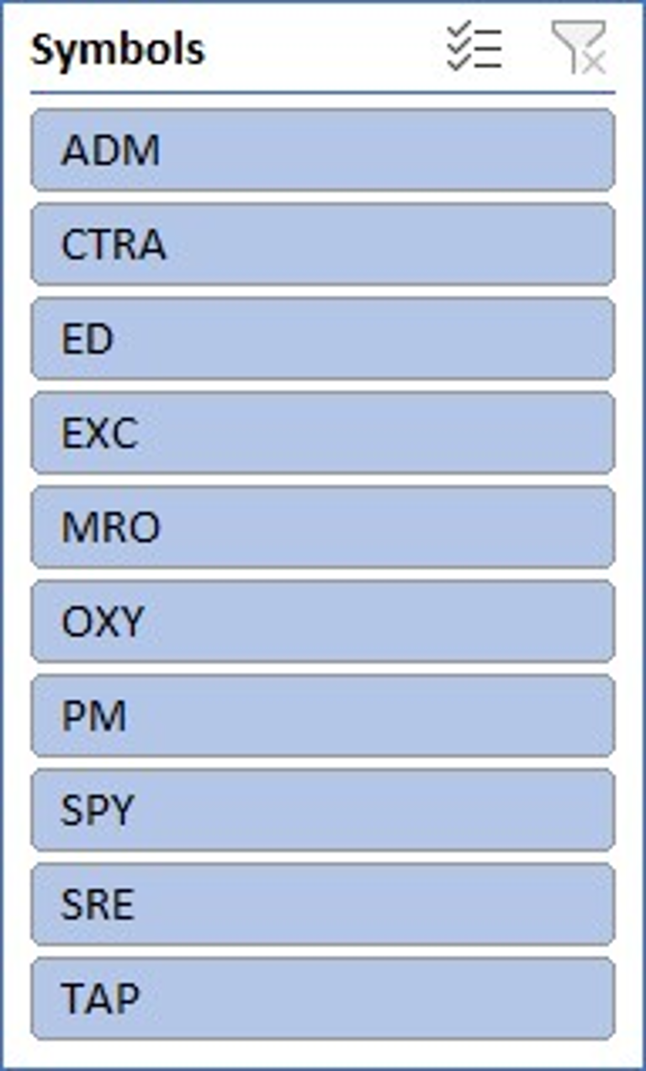

Here we compared the top performing stocks to the S&P500 to determine if any stock has been on a constant uptrend while the S&P500 has been on a constant downtrend.

So far, we have chosen the top three sectors and picked the top three performing stocks within those sectors. Then compared them against each other and to the S&P500. We will then bring in stock metrics to further investigate our stocks and help the stockholders make their final decision. The purpose of this dashboard is to explore stocks in the market that would be beneficial to having a positive return on an investment. With the market being in a downtrend the past few months, it can be hard for new investors to feel confident in their investments and possibly make a mistake. This can lead to a new investor losing money and deciding to refrain from investing into the stock market again.